Explorer

Magnetometer

Quick Start Guide
Rev. 2025-05

Marine Magnetics Corp Tel: +1 905 479-9727 Fax: 905 479-9484
135 SPY Court Email: support@marinemagnetics.com
Markham, ON URL: www.marinemagnetics.com
L3R 5H6 Canada

Contents
1 Introduction 2
1.1 Magnetometer sensor technology 2
2 Connection diagram 3
2.1 RS-232 Interface 3
2.2 Electrical Specifications 4
2.3 Pressure Sensor (optional) 4
3 Layback distance estimation for optimal magnetometer positions 5
4 Operating the Explorer system using BOB Software 6
5 Magnetometer data display in BOB 9
5.1 Profile Plot: Real-time and Review panes 10
5.2 Explorer data in a lab setting 11
5.3 Calibrating the depth sensor zero level 12
5.4 Saving and exporting survey data 12
5.5 Using the magnetometer data terminal in BOB 13
6 Explorer Standard Data Format 14
7 Troubleshooting 15

Introduction
Explorer is a high-sensitivity total field magnetometer packaged into a rugged marine towfish housing designed to be towed behind a vessel (crewed or autonomous), an AUV or a side-scan sonar. Measurement of the magnetic field is performed completely inside the towfish. In addition to the magnetometer, each Explorer towfish contains a leak detector and can be equipped with a depth sensor. Power and communication are supplied to the towfish through a 4-conductor soft tow cable connected to a small power isolator box on the vessel. The communication with the data logging computer is via RS-232 serial interface. For side-scan sonar integrations, a side scan integration cable replaces the soft tow cable and power isolator box.
Explorer command protocol consists of single-byte commands for setting the sampling rate, configuring the Overhauser sensor and the pressure sensor and performing basic diagnostics.
The total power consumption of an Explorer system is 2 Watts, making it an ideal fit for integrations with a variety of platforms.

Magnetometer sensor technology

Explorer magnetometers are based on the omnidirectional Overhauser sensor known for its superb absolute accuracy and lack of dead zones, enabling it to operate in any region of the World. The Overhauser sensor operates on the proton spin resonance principle, which is drastically different from a conventional proton magnetometer sensor. The proton-rich liquid within the sensor has been specifically engineered to allow a principle known as the Overhauser effect to occur within it. The Overhauser sensor delivers higher sampling rates and significantly better sensitivity (one to two orders of magnitude) compared to conventional proton sensors, while using only a tiny fraction of the power and maintaining the same excellent absolute accuracy and operational characteristics.
Marine Magnetics Overhauser sensors are omnidirectional and completely isotropic with respect to magnetic field direction. The only restriction that must be observed is that the towfish must not be oriented vertically with the nose (tow cable) facing directly upwards. This is a restriction with respect to the direction of gravity, not magnetic field.

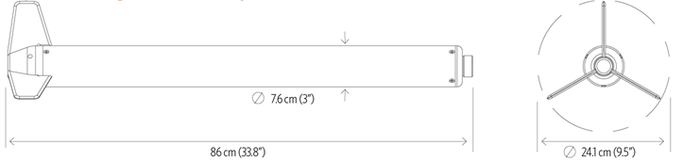

Connection diagram
The Explorer magnetometer system is designed for quick and easy deployment and can be set up without the use of any tools. The following diagrams show how to properly connect the system.
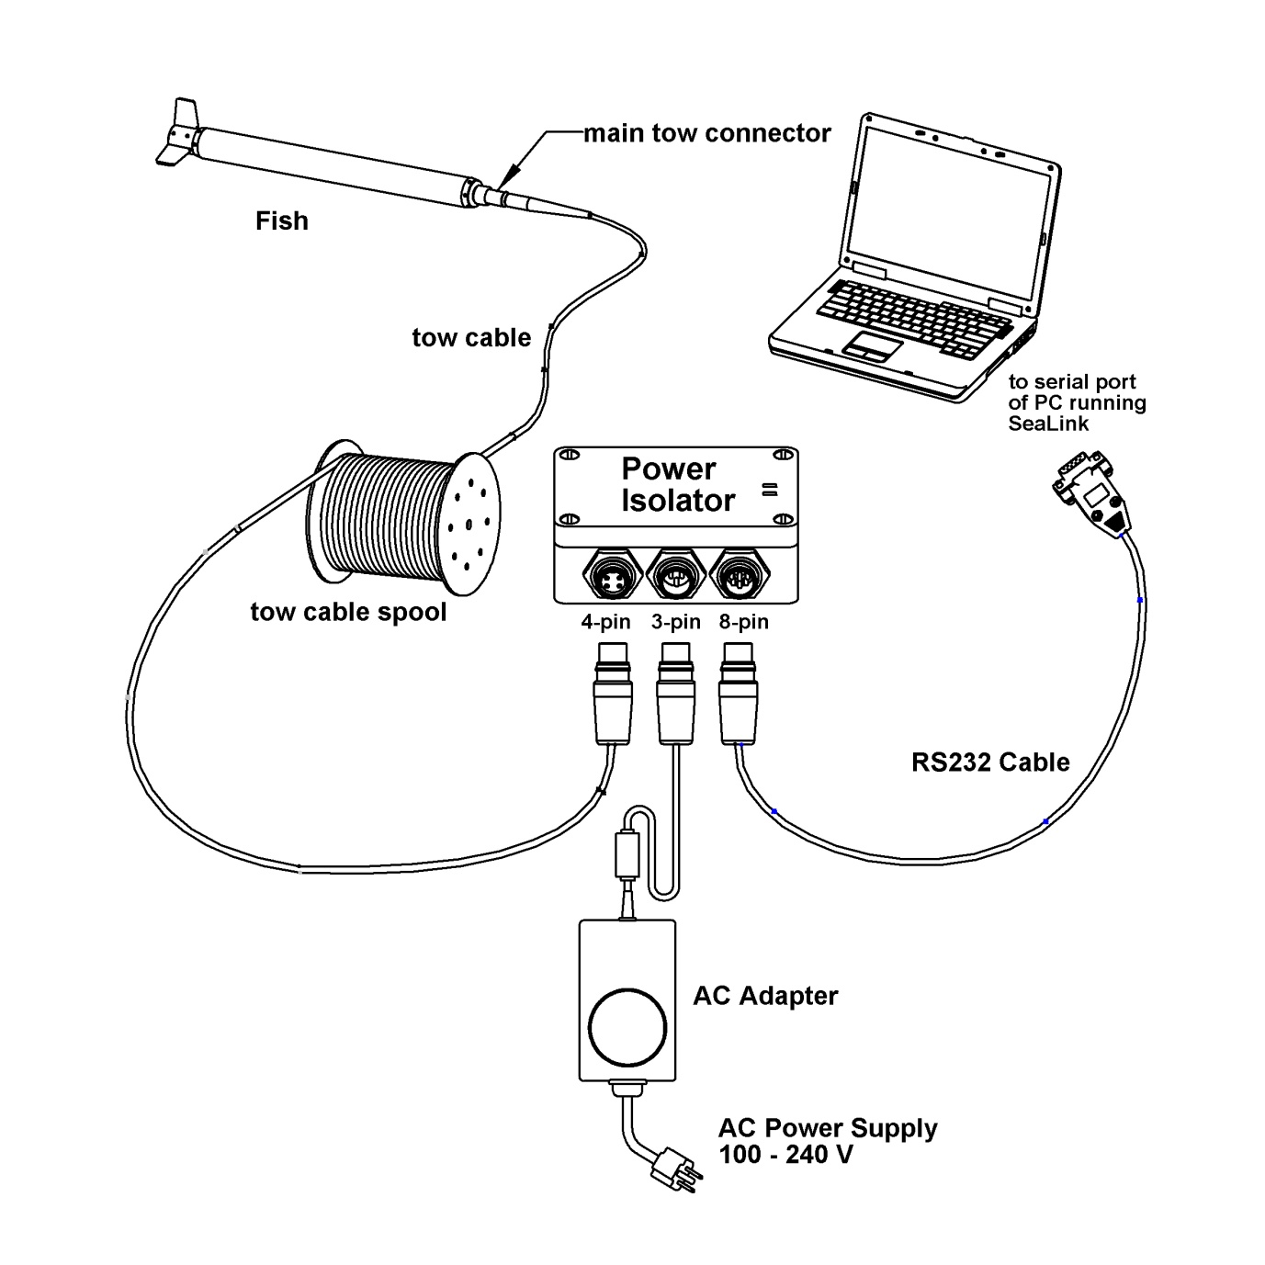
Figure 2-1 - Connection Diagram for surface towed applications using the Power Isolator box and a 24V DC adapter

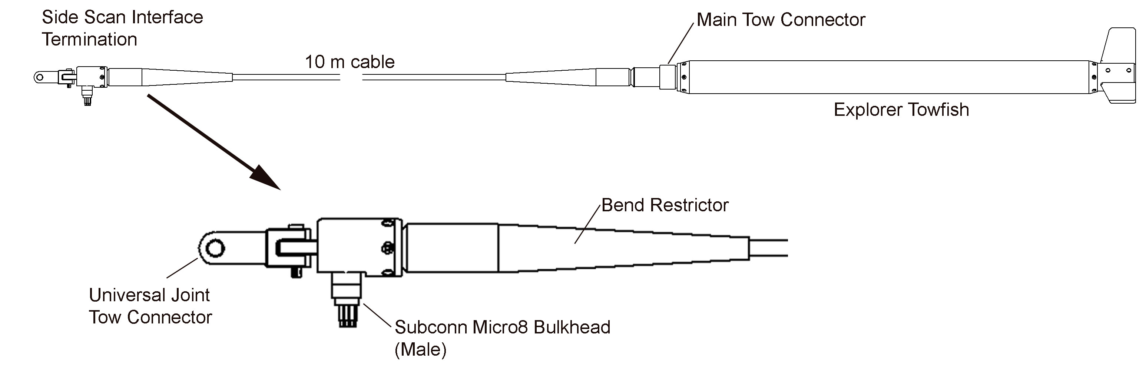
Figure 2-2 - Connection diagram for side-scan Integrations. A test cable and 24V DC adapter are provided
for bench testing communication without the side-scan sonar connected.
The universal joint mechanical coupling link attaches the interface housing to the side scan and allows full rotation in two dimensions. Two coupling link options are available depending on the model of the side scan sonar being used: tab and slot interface couplings.

RS-232 Interface
All communication with the Explorer towfish is via bidirectional full-duplex RS232 using 9600 baud, 8-N-1 scheme (eight data bits, no parity and one stop bit). The Explorer’s baud rate can be configured using the B command. Baud rate options are 1200bps, 2400bps, 4800bps, 9600bps (default), and 19200bps. Power Isolator Box is supplied with either RS-232 or USB cable. The USB interface operates as a virtual COM port.

Electrical Specifications
The Explorer Power Isolator Box (PIB) contains power-conditioning electronics to supply clean power to the Explorer, as well as optocouplers on all communication lines to provide isolation from the PC. Power and RS232 are both fully isolated from the supply ground, providing extremely high immunity to noisy power supplies at all frequencies. The wide input range of +9 to +28VDC allows for operation with both +12VDC and +24VDC vehicle batteries.
A PIB can communicate with an Explorer towfish across up to 200m (656ft) of the standard Explorer tow cable. The length of the tow cable is limited by the RS232 communication baud rate.
The PIB is supplied with a universal AC power supply, with input range of 115/240VAC, at 50/60Hz, and produces a constant +24VDC to power the PIB and Explorer system.

Parameter | Min | Typ. | Max | Units
Explorer Input Voltage | 8 | 24 | 40 | VDC
Explorer Input Power | - | 2 | 2.7 | W
Integration Max Output Current – fused | - | - | 500 | mA
RS232 Baud Rate | 1200 | 9600 | 19200 | Bps

Table 2-1 - Electrical specifications of the Explorer magnetometer
The electrical connector on the Explorer towfish is a 4-pin male Subconn micro-circular connector (P/N: MCBH4M).
Tow cable that connects to the Explorer has a 4-pin female connector (MCBH4F or MCIL4F).
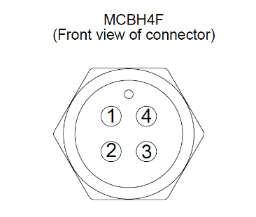
  MCBH4F | Signal
  1 | PWR V+
  2 | PC -> MAG (RS232)
  3 | MAG -> PC (RS232)
  4 | PWR GND / RS232 GND
Figure 2-3 - Tow cable connector wiring for connecting to the Explorer towfish

Pressure Sensor (optional)
Pressure (depth) sensor options available in Explorer towfish are outlined in Table 2-2. The choice of the sensor affects its precision as well as the maximum pressure limit that it can withstand before sustaining permanent damage. Exceeding this pressure can cause a change in the calibration tuning of the sensor, and its accuracy may suffer as a result.
Note that the standard Explorer housing as a whole is rated to a depth of 1000m, which should never be exceeded or damage to the housing may result.
Table 2-2 - Pressure sensor options
Depth Range | Pressure Range | Precision | Housing
345 m | 500 PSI | 0.1 m | 1000m standard
1000 m | 1500 PSI | 0.3 m | 1000m standard

The pressure sensor is an analog device that may drift with temperature and with time. For proper operation, the pressure sensor’s zero-level should be reset prior to every survey. For best results in calibration, the towfish should be submerged to allow the temperature of the pressure sensor to reach the water temperature and then retrieved back to air to calibrate the zero-depth pressure. Use the p (small p) command to set the zero pressure level. Please refer to the Explorer Operating Manual for further details.

Layback distance estimation for optimal magnetometer positions
BOB software computes the position of the magnetometer sensor(s) during the survey using a combination of the fixed layback distance and the curve of the vessel’s track. For best positional accuracy, the lengths of all system components must be included when determining the total ‘layback’ distance between the GPS receiver mounted on the vessel, and the magnetometer sensor.
The side-scan integration cable is 5.25m long, while the magnetometer sensor is located at the tail end of the towfish, adding a further 0.75m. This combined magnetometer offset from the side-scan sonar towing connection to the tail end of the magnetometer towfish (sensor location) amounts to 6m.
When used in combination with a side-scan sonar, one additional unknown dimension must be accounted for: the offset between the GNSS receiver on the vessel, and the side-scan integration cable tow point. If this distance can be approximated as a constant with an accuracy of +/- 0.5m, it may serve as a sufficiently accurate initial estimate for layback calculations. Total layback can be fine-tuned during post-processing after initial magnetic field maps are generated, as part of the layback (lag) correction step.
For best results when towing the magnetometer with a side-scan sonar, it is recommended to use an acoustic positioning beacon (e.g. USBL) to determine the position of the side-scan sonar and feed that time-stamped position data into the magnetometer data logging software in combination with the magnetometer offset. Please note that the date and time included in the USBL data stream must be synchronized with the date and time of the magnetometer system data stream (i.e. they must use the same common time zone. UTC time is recommended).

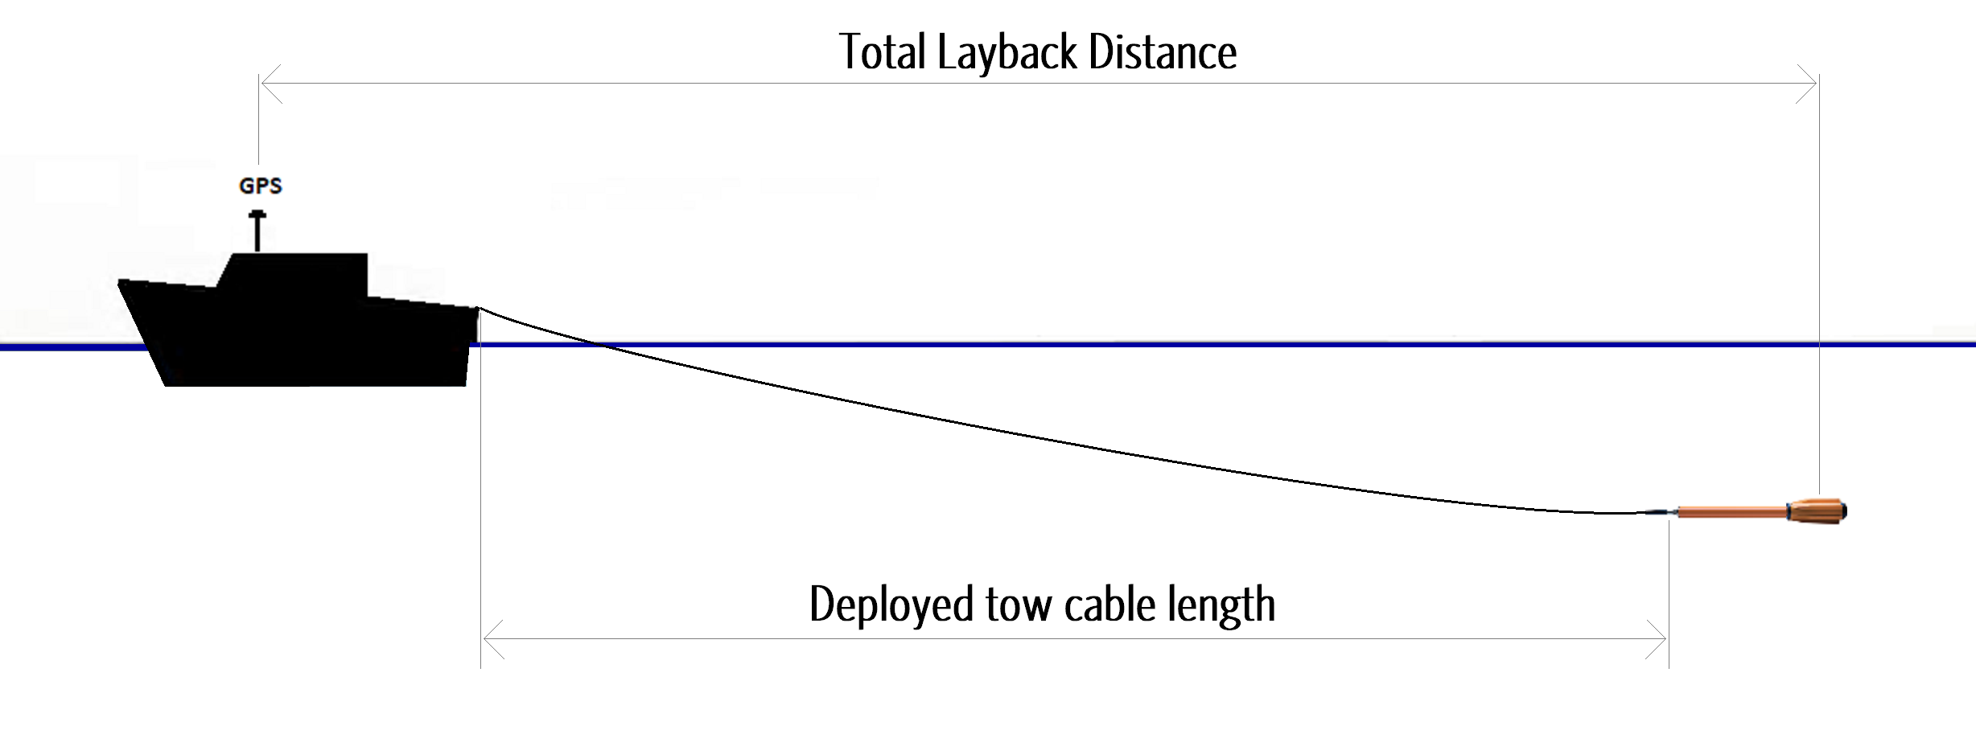
Table 3-1 – Layback distance estimation for surface towed magnetometers

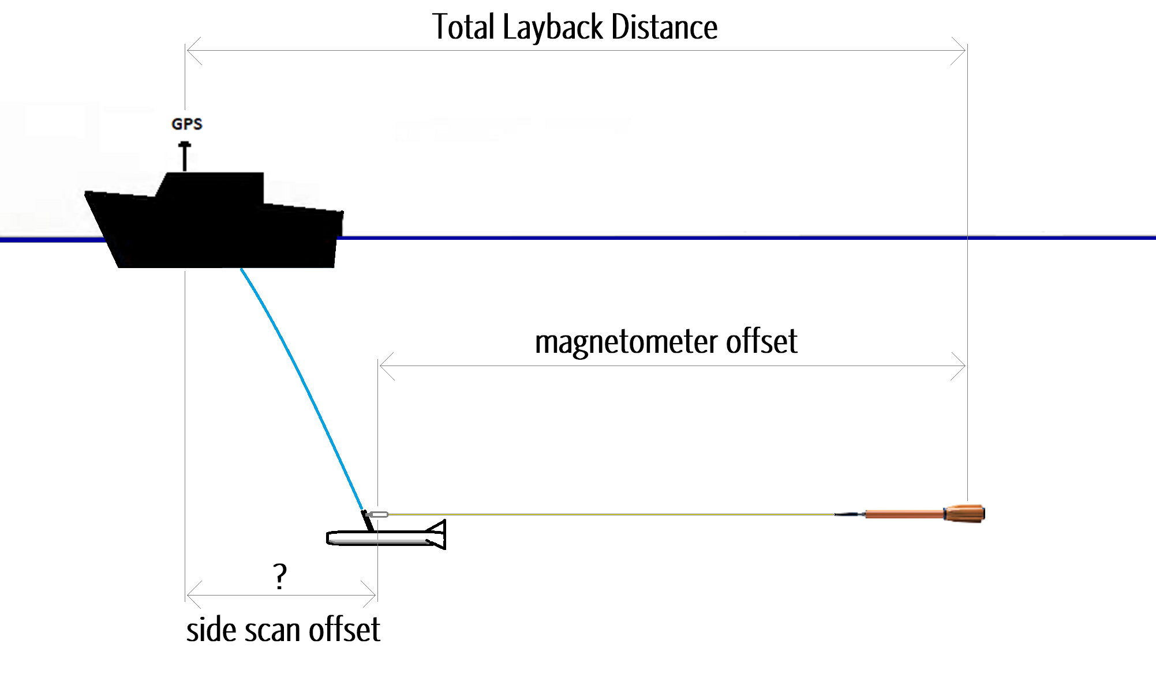
Table 3-2 - Layback distance estimation for side-scan sonar integrations
Tow cable length must be adjusted appropriately for the length of the magnetometer system before determining the magnetometer offset.
The magnetometer sensor is located at the back of the Explorer towfish, increasing the effective length of the tow cable.
Table 3-3 - Adjustment required to determine the effective tow cable length for different magnetometer models
Magnetometer model | Tow cable length adjustment
Explorer | + 0.75 m

Operating the Explorer system using BOB Software
Marine Magnetics BOB is a magnetometer interface software that provides data logging, survey planning and data corrections for all Marine Magnetics products. Additional processing and data visualization features can also be activated using the BOB Analytic Module (BAM) license. Free BOB software is available from the following URL: https://bob.marinemagnetics.com/
Described below are BOB Setup Assistant steps for configuring a new Explorer system survey.
- Create a new survey and select the appropriate magnetometer type: SeaSPY/Explorer, and select No for altimeter.
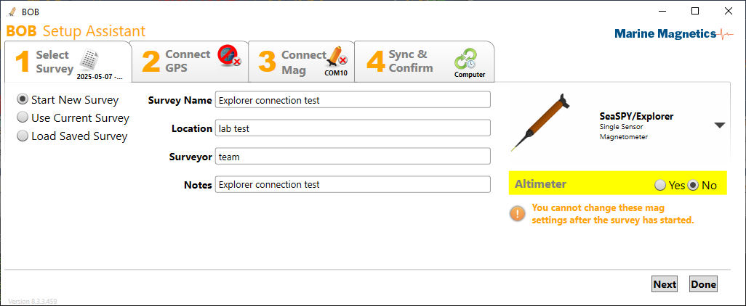
Figure 4-1 - Starting a new Explorer (or SeaSPY) survey in BOB software.
Note that the magnetometer type cannot be changed after the survey has been created.
- Connect to the survey GNSS via COM port.
BOB supports GNSS connections via RS-232 or virtual COM port for survey position and time synchronization. The following NMEA data messages are supported by BOB: GGA, RMC and ZDA. A GNSS with 5Hz or higher update rate is recommended for best survey navigation experience. Default Layback is set to 15.5m, and can be modified later at any point via the BOB GeoPlot window, and fine-tuned during post-processing.
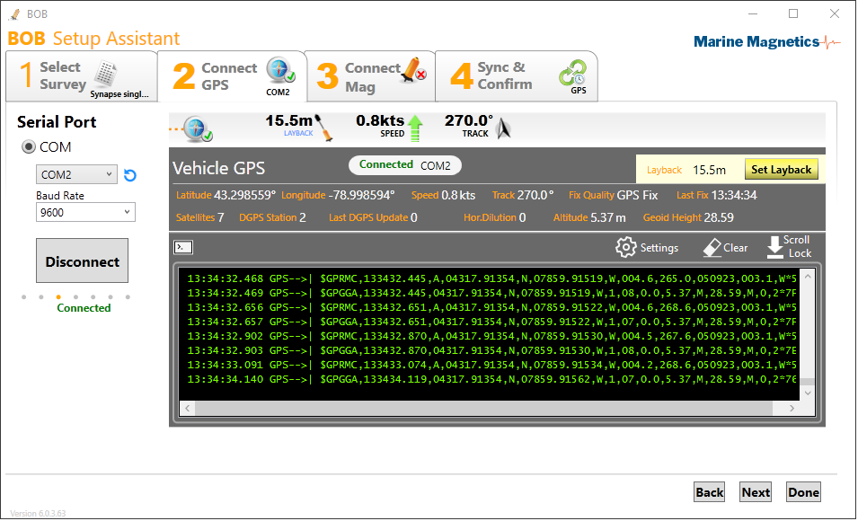
Figure 4-2 - GNSS data terminal view. Note that both RMC and GGA strings contain UTC time and position information,
but the RMC may have better position precision in some cases, and only RMC contains the calendar date.
If RMC is not present, ZDA will be required to determine the correct calendar date.
BOB uses GNSS time to synchronize the magnetometer internal clock, which time stamps all incoming data. It is important to have the same date and time configured for the entire survey system (e.g. side scan sonar, USBL and magnetometer) to ensure everything is properly aligned and to enable post processing data corrections such as base station / diurnal correction.
- Connect to the Magnetometer via COM port.
BOB supports magnetometer connections via RS-232 or virtual COM port.
9600 is the standard baud rate for Explorer. A good practice is to set up the COM port connection before powering up the Explorer magnetometer.
Refer to Explorer Operating Manual for details on RS-232 baud rate configuration.

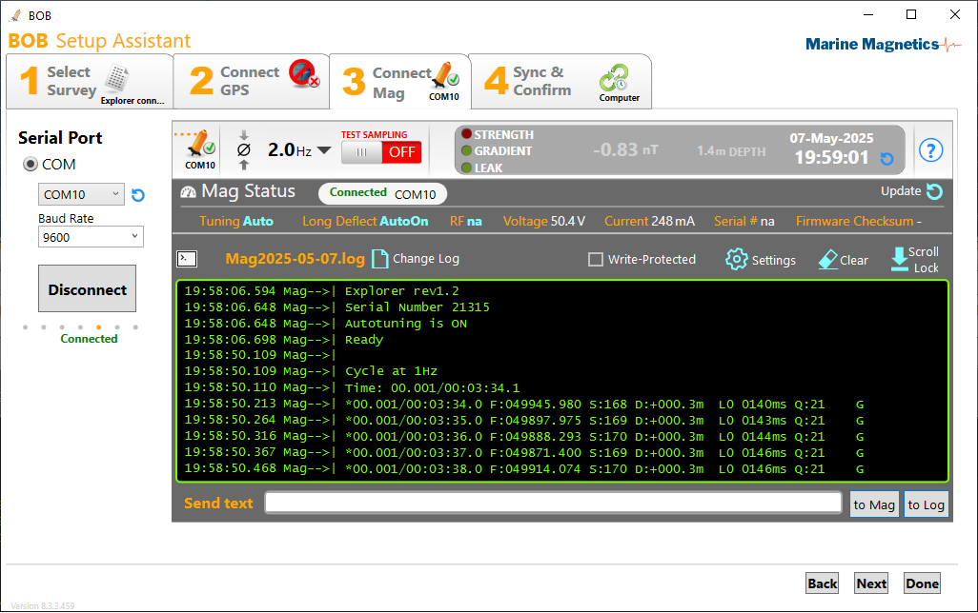
Figure 4-3 - Typical data output of an Explorer system during start-up

Explorer will transmit a power-up header when first powered up. It will then resume cycling at the sampling rate that was last used before it was powered off or remain in idle state if sampling was stopped at the end of the previous session. Note that the power-up header will be missed if the COM port connection is established after the Explorer has been powered-up.

Explorer’s internal clock is reset to zero when power is disconnected. It is good practice to always set the magnetometer date and time by syncing it to the GNSS (or the data logging computer) before beginning to record data. This can be done in Step 4 of the BOB setup.

Please refer to section 6 for details on Explorer data format.

- Finalizing the configuration in BOB
The final step 4 in BOB Setup Assistant summarizes the survey parameters and COM port connections and offers options for time synchronization reference clock device for the magnetometer towfish.
For best results and to avoid issues in post processing, the magnetometer should be synced to the GPS/UTC time. This requires a GPS connection. Without a GPS connection, the Mag clock can be set to either PC time or entered manually. For best results ensure that your PC is configured to automatically sync its system time to the Internet and is configured to use the correct time zone. BOB will convert the current PC Windows time to UTC time based on the time zone configured in Windows.
When using a USBL as a position source device, please make sure that the time stamps supplied by the USBL system are also in UTC time, because BOB will assume GPS-like input devices to represent the current UTC time.
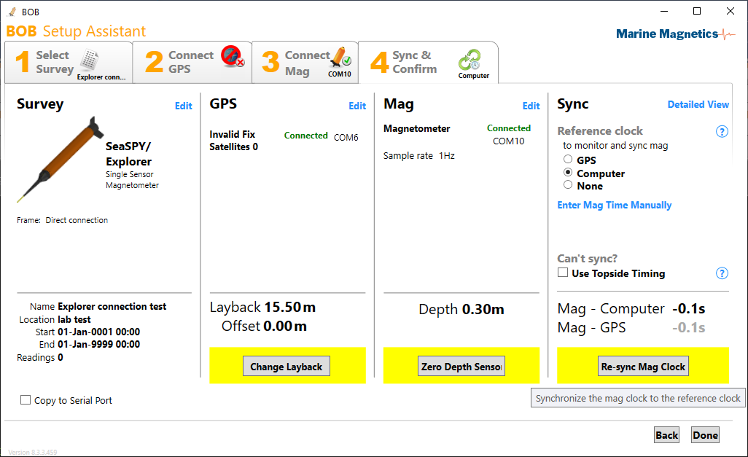
After synchronizing the magnetometer clock to the reference clock device, you should be able to return to Step 3 of the setup and verify that the magnetometer data terminal shows readings with correct time stamps.
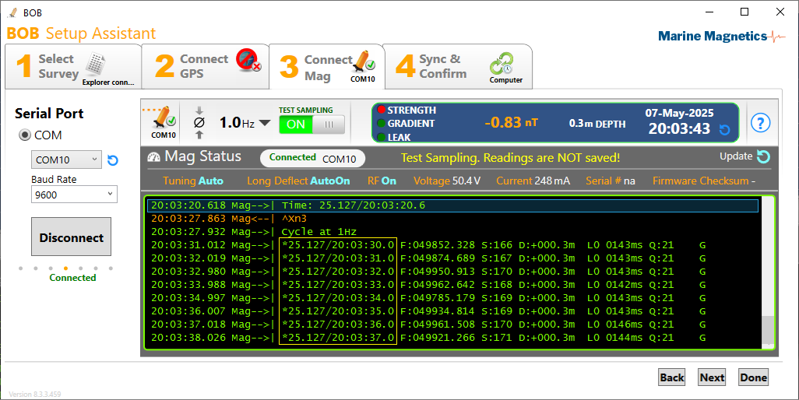
Figure 4-4 - Mag data terminal view with a properly synchronized mag clock.
The time column on the left is the System Time in UTC that BOB uses as overall backup time reference.

Magnetometer data display in BOB
This section illustrates features of BOB and BAM (BOB Analytic Module) using examples from a Synapse Horizontal Gradiometer. While the number of data signals is different, the overall interface will look the same when used with an Explorer magnetometer. Please refer to the BOB User Manual for further details on all features and functions.
The BOB user interface is divided into two windows: The Main BOB window which contains the sensor signal profile graphs and a data table below, and the GeoPlot window which displays the map view location of the survey equipment and data points.
The Layers panel of the main window shows magnetometer data singles grouped into Fields, Positions and Attitude* groups (*when equipped with an IMU). The vertical scale for each signal group can be selected individually or as a group by selecting the group heading in the Layers panel and right-clicking on it. You can also multi-select individual components by holding down the Ctrl or Shift keys.
The vertical slider to the left of the Layers panel can also be used to adjust the vertical scale.
The profile traces of the Fields group can be dragged up and down with a mouse while holding down the Shift key, and scaled via the layers panel for convenience and comparison. The traces in Position and Attitude groups can only be scaled but not dragged, as they have predefined reference “0” positions. The depth zero reference level is the top of the graph, representing the water's surface. The altitude zero reference level is at the bottom of the graph. The Pitch and Roll traces are centered for displaying both positive and negative deviations.
The sampling button at the top left of the toolbar also serves as the sampling indicator. A drop-down menu shows a selection of available sampling rates.
When sampling is enabled, the current magnetometer time and magnetic field reading are displayed above the profile plot. Depth, Altitude, and Bottom alert indicators can be configured by right-clicking and selecting the minimum and maximum thresholds.
GeoPlot window features a multi-layered map view of the collected data and real-time magnetometer position. With a BAM license activated, the data can be visualized in several interpolated maps, including Total Field, Analytic Signal, and Partial Gradient* maps (*for gradiometers).
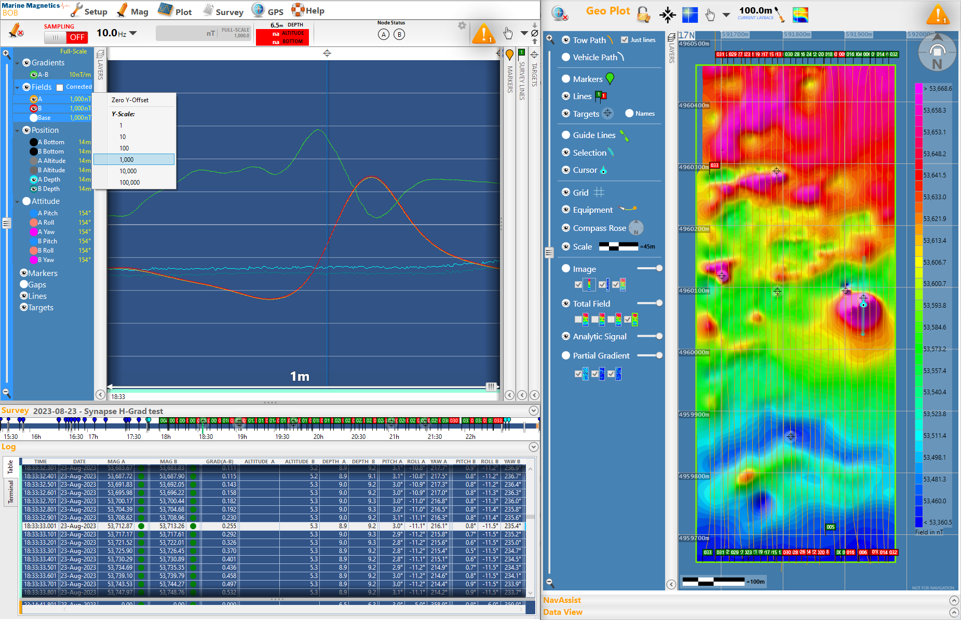
Figure 5-1 - Typical BOB user interface when reviewing existing Synapse Horizontal Gradiometer data and interpolated maps generated in BAM.

Profile Plot: Real-time and Review panes

The Profile Plot window in BOB contains a vertical divider that can be used to split the view into the Review pane (left) and the Real-Time Readings pane (right). The Horizontal scale (time span) can be set separately for each pane using the horizontal slider at the bottom of each pane. The timeline bar below the profile plot will highlight the time interval currently displayed in the Review Pane.
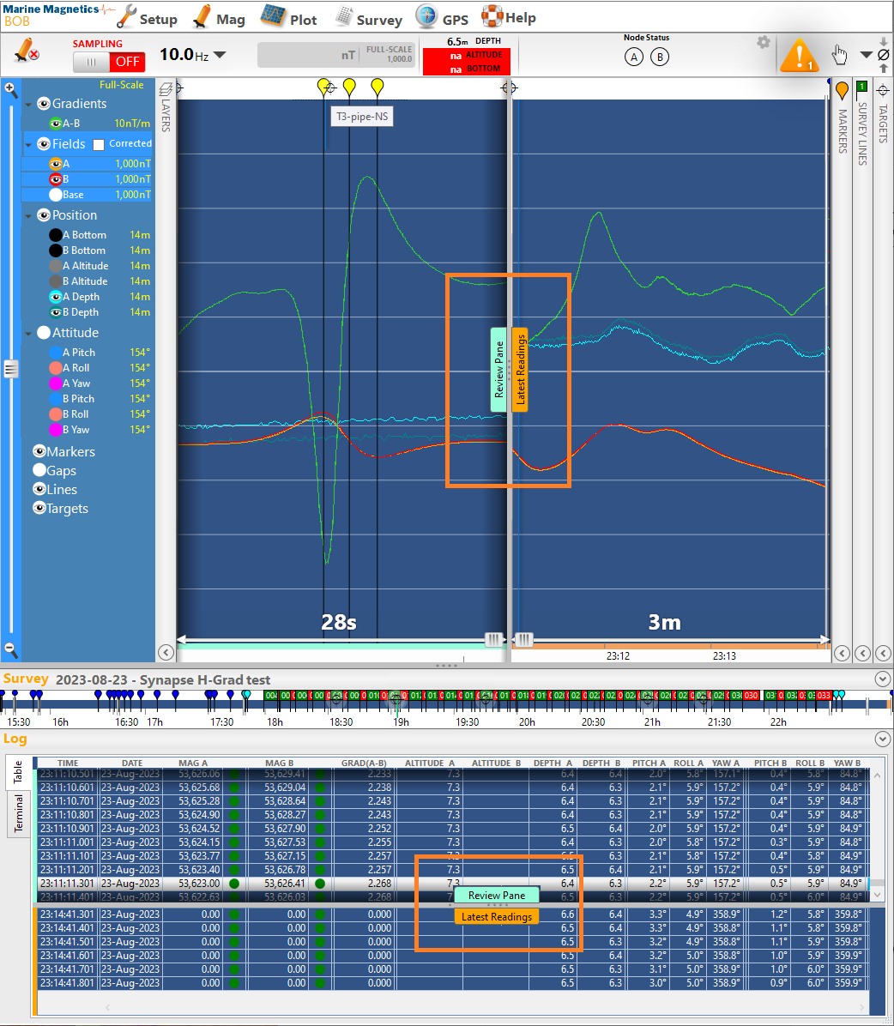
Figure 5-2 - BOB Profile Plot can be divided into Review (left) and Real-time (right) panes, with different time spans for each.
The Log table below the plot can be similarly divided with a horizontal bar.

Explorer data in a lab setting
When the magnetometer is placed inside a building or on the deck of a vessel, it may be in proximity to materials and appliances that cause magnetic interference and noise. As a result, the magnetometer data may appear noisy, but in fact it reflects the rapidly varying ambient magnetic field.
Moving the magnetometer to a non-magnetic location should eliminate the observed noise. This normally requires placing it away from any buildings, structures or vehicles, and elevating it at least 1m above the ground to help minimize the magnetic gradients.
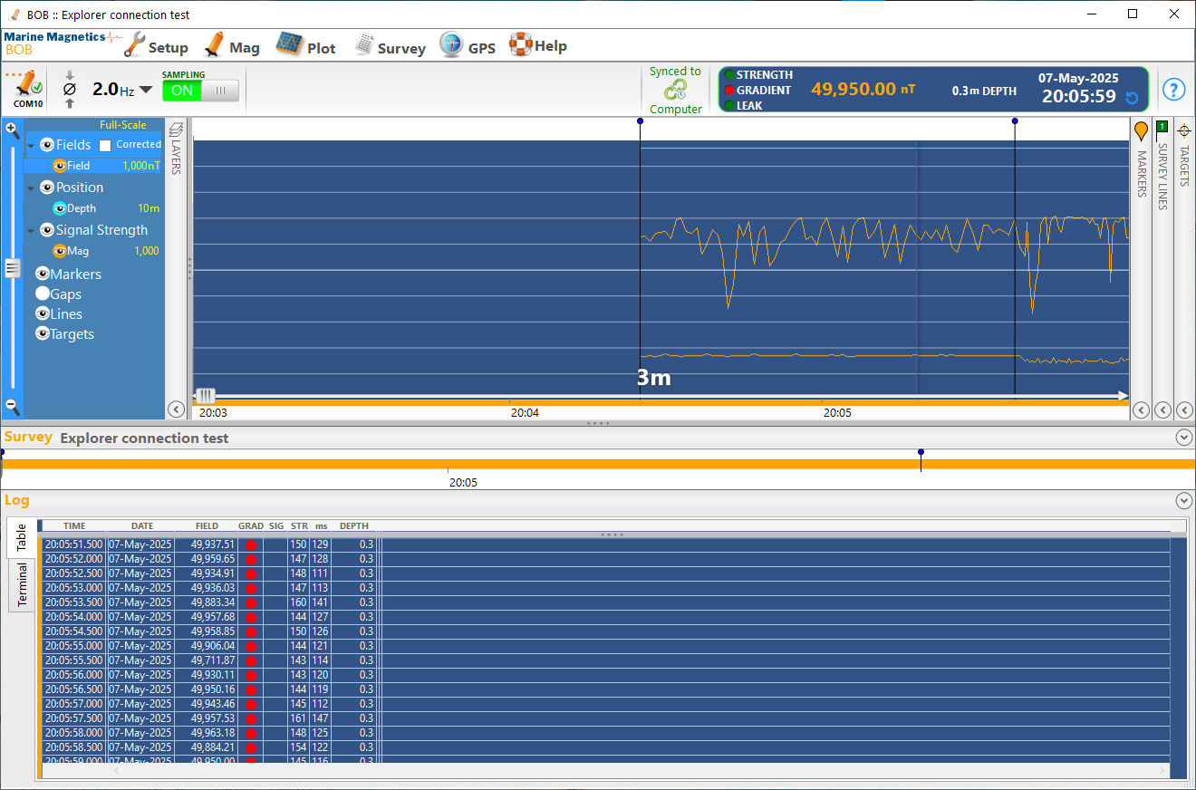
Figure 5-3 - Noisy magnetometer data may be observed when Explorer is positioned inside a lab or on deck of a vessel.
Magnetic gradient warnings are indicated in red beside each reading and are usually accompanied by low signal strength
and shortened measurement time.

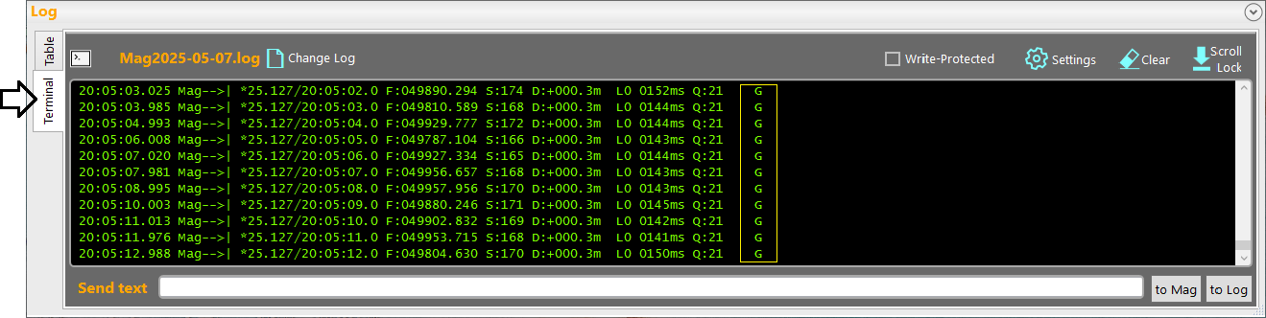
Figure 5-4 - When viewed in a mag data terminal, noisy data readings are usually accompanied by a magnetic gradient warning indicator (G)
Please refer to Section 6 and the Explorer Operating Manual for an explanation of the data format and warning indicators.

Calibrating the depth sensor zero level
Calibrating the pressure sensor’s zero-depth level should be done at the start of each survey, after allowing the magnetometer towfish to adjust to the water temperature and then bringing it out of the water to set the zero-depth level.

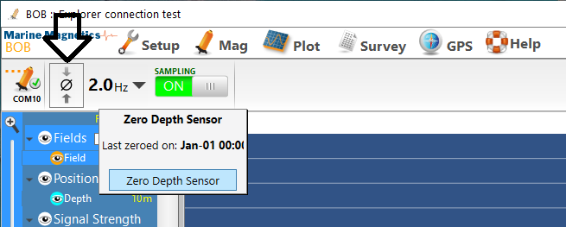
Figure 5-5 - BOB offers a button for setting the zero level of the depth sensor.
Alternatively this may be done by sending a p command via the mag data terminal

Saving and exporting survey data
All data collected by BOB are always stored in the BOB survey database whenever sampling is enabled. The database is stored internally and cannot be directly accessed, but it can be backed up to a file for archiving or exported in CSV format for processing in 3rd party software.
To create a backup copy of the BOB survey database, use Survey > Backup to File. This will create a file with the extension .MMS, that contains all the data logged during the survey, including all markers, targets and BAM maps. This file can be imported into a BOB installation on another computer for sharing or post processing.
To export survey data for post-processing in 3rd party software, use the menu selection Survey > Export Survey Log. This option offers a flexible interface for selecting specific data channels and corrections to be applied and exported. The resulting file will be ASCII text formatted as CSV (Comma Separated Values), or a space-separated value file.
Please refer to the BOB User Manual for further information.
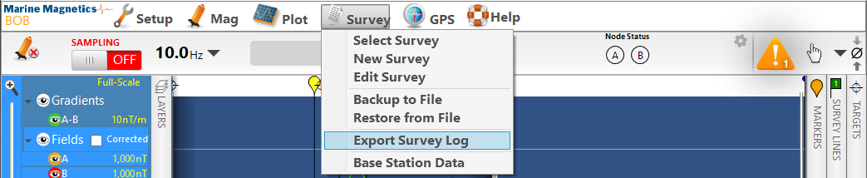
Figure 5-6 - Survey data can be backed up as a BOB-compatible backup (MMS) or exported as universal CSV format

Using the magnetometer data terminal in BOB
BOB provides a data terminal for sending commands to the magnetometer, checking incoming data and responses.
A complete log of all COM port communication is saved whenever a COM port is open.
A command menu can be requested by sending a ? command.
Magnetometer serial number can be obtained by sending a ! command, and input power and magnetometer status can be checked using the D command.
Please refer to the Explorer User Manual for details on all commands.
Data received from the magnetometer is shown in green, with an arrow pointing to the right.
Data and commands sent to the magnetometer are shown in orange, with an arrow pointing to the left.
In addition, comments and notes can be written directly to log file by typing // at the start of the sentence and are shown in blue.
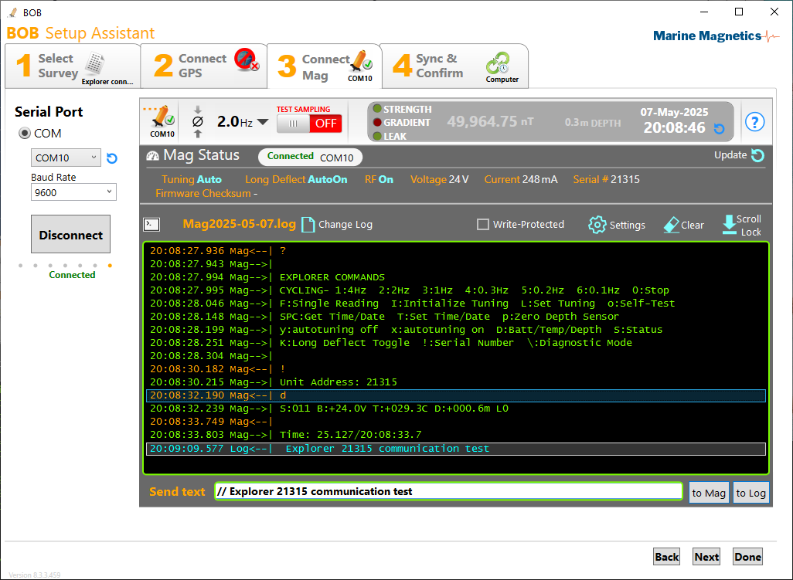
Figure 5-7 - Magnetometer data terminal view showing a command menu and sample responses

Explorer Standard Data Format
Data that is presented by the magnetometer during cycling can appear in one of three formats: Standard, Compact and SIS-1000. An operator can choose between formats using the b command in diagnostic mode. Please refer to the Explorer User Manual for details on all formats and commands.
The Standard data format is the most commonly used, and is usually the default setting when an Explorer magnetometer is first shipped. It is fully compatible with the SeaSPY standard data string. The data string appears as follows:
Format: | *YY.JJJ/HH:MM:SS.S F:FFFFFF.FFF S:SSS D:+DDD.Dm L0 TTTTms_Q:QQ !!!! CR LF
Example: | *25.127/20:05:02.0 F:049890.294 S:174 D:+000.3m L0 0965ms Q:99 G

The first character of each line is always * (ASCII code 42). This leading character is supplied for automated data collection systems that require periodic synchronization with the data stream.
Each letter shown in italics stands for a digit of a particular record in the reading.
Number | Description
YY | Year
JJJ | Julian day (Day of Year: 1-365)
HH:MM:SS.S | Time of Reading  It is recommended to set the magnetometer clock to the correct time (ideally UTC time) during every survey. This time will reset each time the power to the towfish is interrupted.
F | Magnetic field (nT).
SSS | Signal Strength of reading. This is a raw number generated by the magnetometer that gives (in part) a good indication of the quality of the final total field measurement. Anything over 80 is considered an acceptable signal, and anything over 130 is considered excellent.
DDD.D | Towfish Depth. The value shown is in meters. The depth sensor can be calibrated using the P and p commands. (Only available if depth sensor installed)
L0 | Leak sensor output {0 : no leak; 9 : indicates that a leak is present}.
TTTT | Measurement time (ms). Measurement time depends on the sampling rate, and ideally should be the magnetometer’s cycling time interval minus 35ms, with a maximum of 965ms.  1 Hz cycling: 965ms measurement time (i.e. 1000ms – 35ms = 965 ms)  2 Hz cycling: 465ms measurement time  4 Hz cycling: 215ms measurement time  If you see a G warning message at the end of the data string, it indicates that the measurement was prematurely terminated due to a high magnetic gradient condition. The measurement time then tells you how severe the gradient is.
QQ | Signal quality. This is a two-digit number between 00 to 99. The left digit is a good indication of signal strength, and the right digit indicates how much information was available for measurement.
!!!! | Warning Indicator Flags {WGPM} (if present; otherwise spaces).  G indicates a high magnetic gradient, which may happen when testing in a lab or on deck of a vessel.
CR | Carriage Return (ASCII code 13).
LF | Line Feed (ASCII code 10).
table 6-1: Standard Explorer Data Format Description

Troubleshooting

Please refer to the Explorer Operating Manual for details on the operation of the magnetometer.
For normal operation, the Explorer should be configured to have Auto Tuning enabled, and Long Deflect to be set to Auto. Using the correct baud rate and a clean source of DC power in the range 12-24V should enable you to communicate with the magnetometer.
If no data is being received, check the tow cable and serial data cable connections.
If you need additional support, please contact Marine Magnetics technical support. We will be happy to help!

Contact Us:
Tel: +1 905 479-9727 Fax: +1 905 479-9484
Email: support@marinemagnetics.com URL: www.marinemagnetics.com

